***Steps to Encrypt Password:-***

1. Open the Eclipse and select encryptPassword.java file under <Project Name>🡪src/test/resources🡪Utilities folder(marked in yellow in below snapshot)

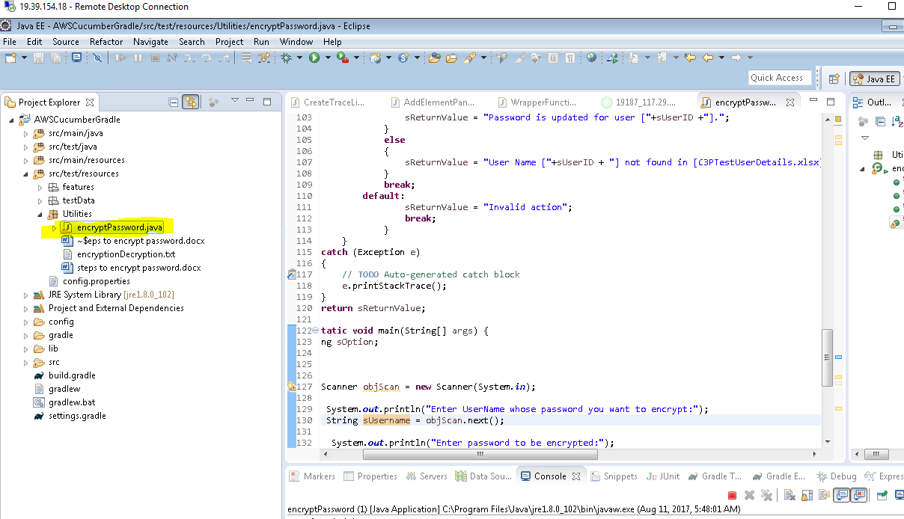

1. Do RMB on encryptPassword.java file and select the “Run As🡪Java Application) menu as shown in the below snapshot to run the class as Java application.

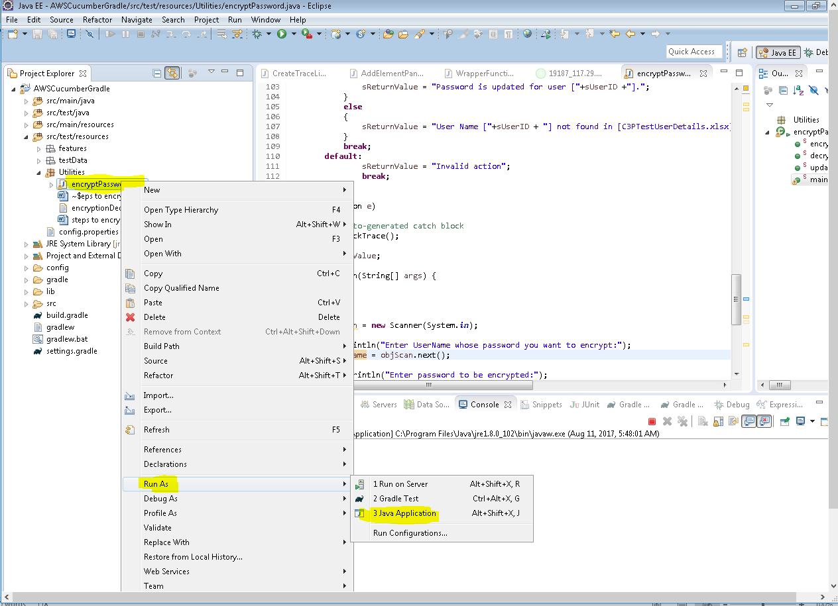

1. Program is executed and in console it asking to “Enter **UserName** whose password you want to encrypt:”.

Enter Username and hit Enter key as shown in below.

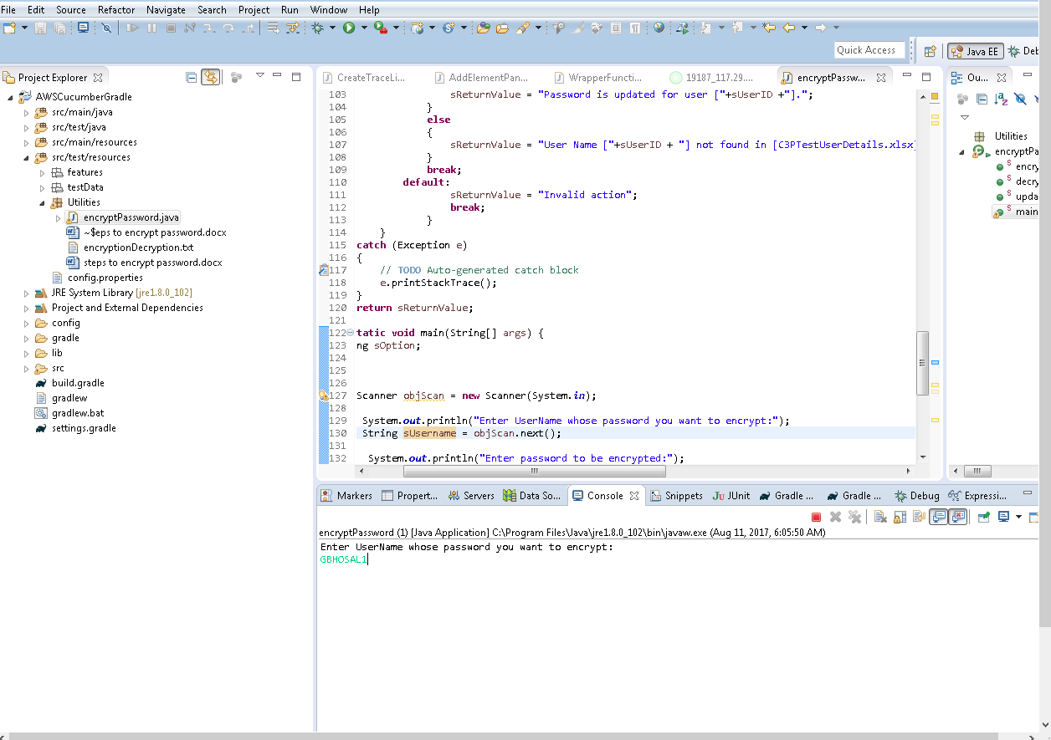

1. Then Enter the Password you want to encrypt and hit Enter key

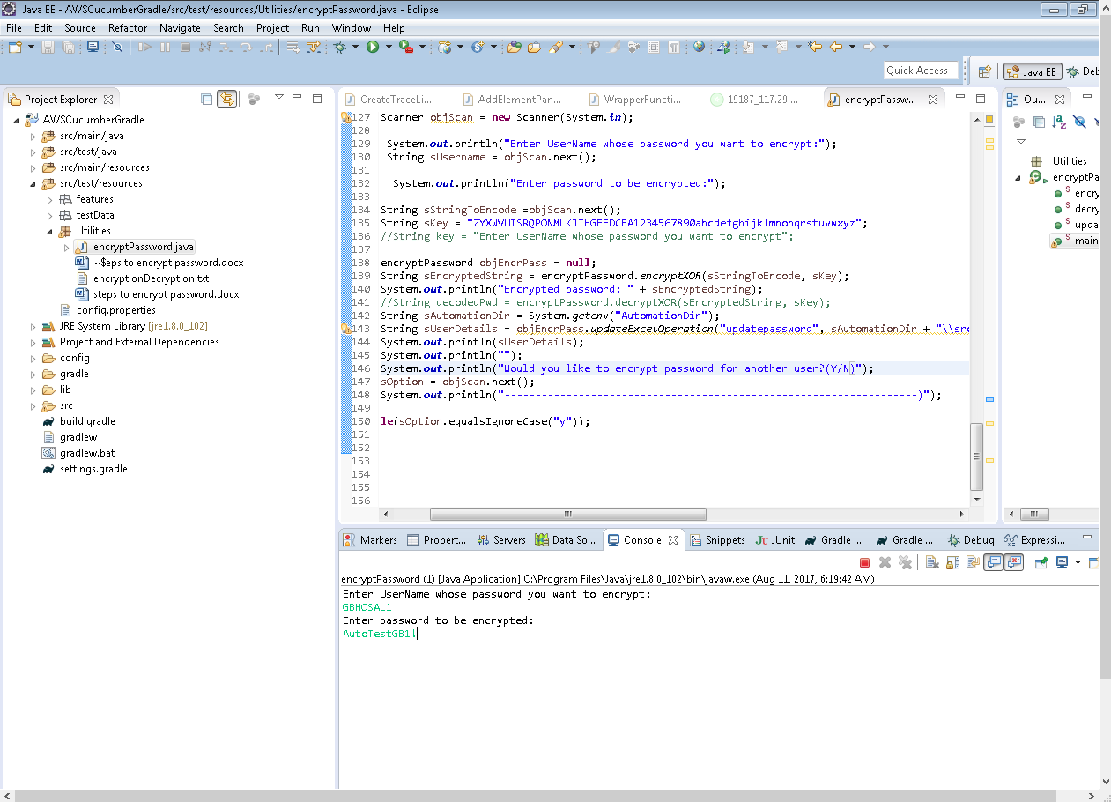

1. Excel file is updated and you get message on console for successful password update as below

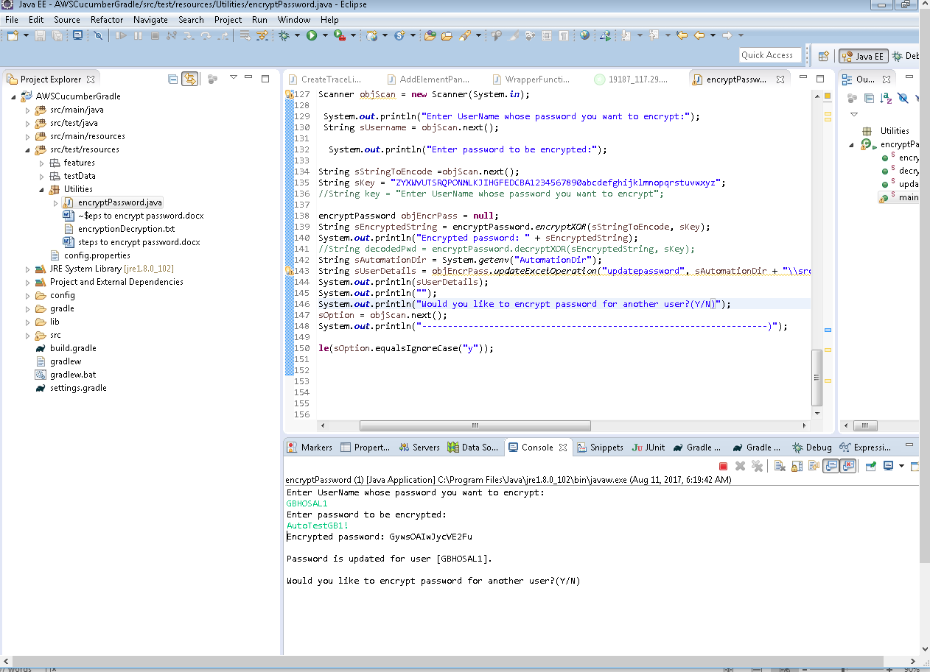

1. If you want to encrypt password for another user then press “Y” and hit Enter key to repeat the steps as above

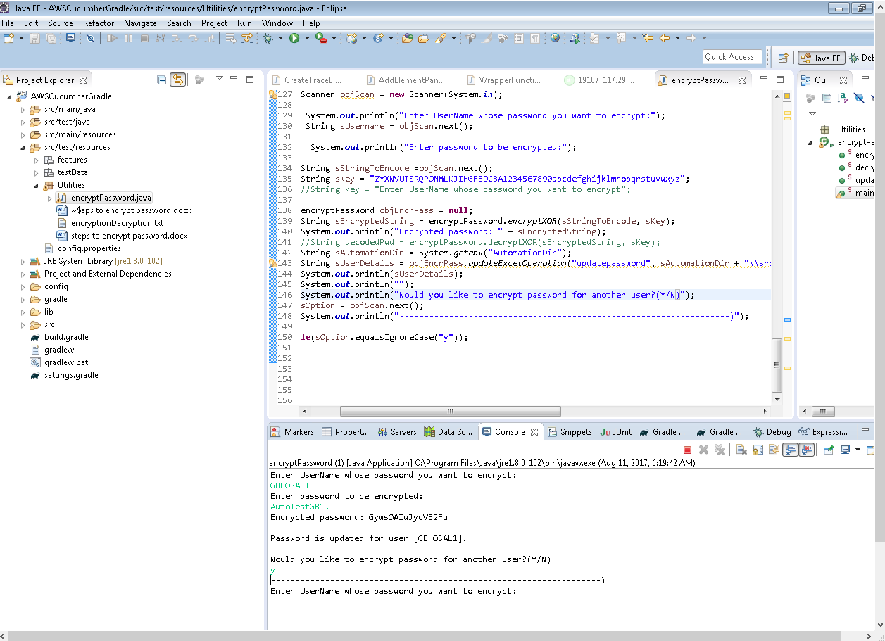

1. If you don’t want to encrypt the password for other users then press “N” and hit enter Key.

